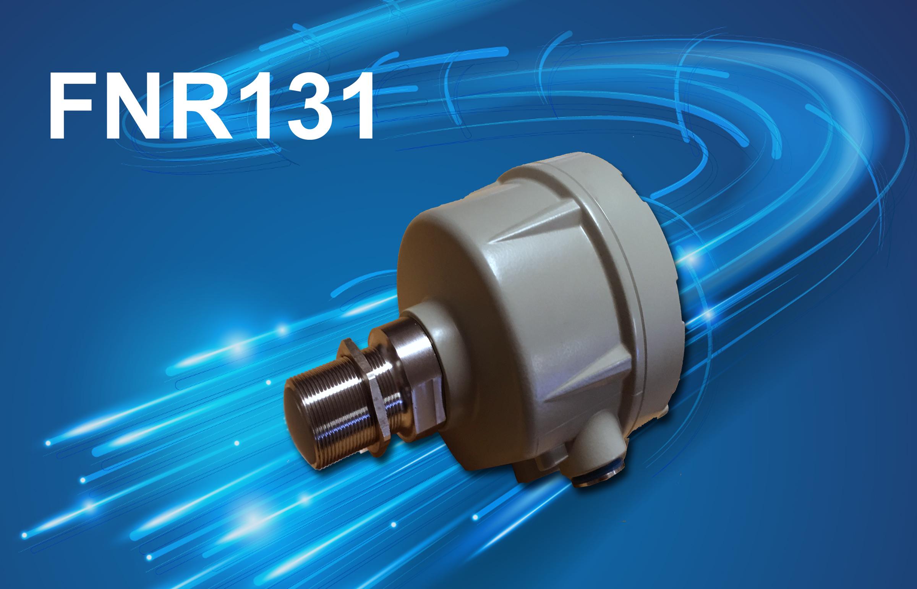

Série
FNR
Wave sensor / Microwave Detector
Flow Sensor & Blockage
For Solid Products

www.telemetrix.fr



Client | Matériel | Date
□ FNR131K □ Fix :
□ FNR131H □ GTR 1½

Description
The FNR131 detector uses Doppler technology to send radar waves to bulk product to eventually push out or clear the jam. Detection is based on the speed of the product, speed needs to be a minimum of 0.1m/s and the direction in which the product moves will have no effect.
Measurement does not come in contact with the moving product in a metal pipe (1) or neither on a distance from 0 to 800mm.

Example:
- Free falling screws from a conveyor belt...
- Pneumatic Transportation

(1) In the case of a metal pipe, it is necessary to have a cross opening of 25mm minimum in diameter so that radar waves can spread.

General Characteristics

Housing | Aluminum and epoxy treatment
Antenna | INOX (except P in PTFE version)
Protection | IP66
Ambient Temperature | Standard :-10 to +80°C  High temperature : -10 to 800°C  (Max total in continuous external temperature 40°C)
Frequence | 24.125 Ghz (Bande K)
Maximum Operating Pressure  (Ref. FTZ & PTT) | 16 | dBm
Maximum Pressure | 1 | Bar
Detection Zone | 0 à 800 | mm
Detection Angle | 7 | °
Detection Speed | 0,1 à 30 | M/s
Power Supply | 24VDC+-10 % 0.5 A MAX
Relay Output NO/NF | On a Relay contact OR 250V 3A SPST
Static Output Q0 | Active output 24V 0.3 A MAX
Trigger Delay | 0 to 30 seconds (TURN ON / TURN OFF selection)
Weight | 1 | kg

Identification
FNR131 __ - __

Version
Standard INOX -10°C à +55°C K
PTFE -0°C à +40°C P
High temperature +800°C H
Explosive atmosphere version A

Fixation
INOX Thread M30x1.5 M30
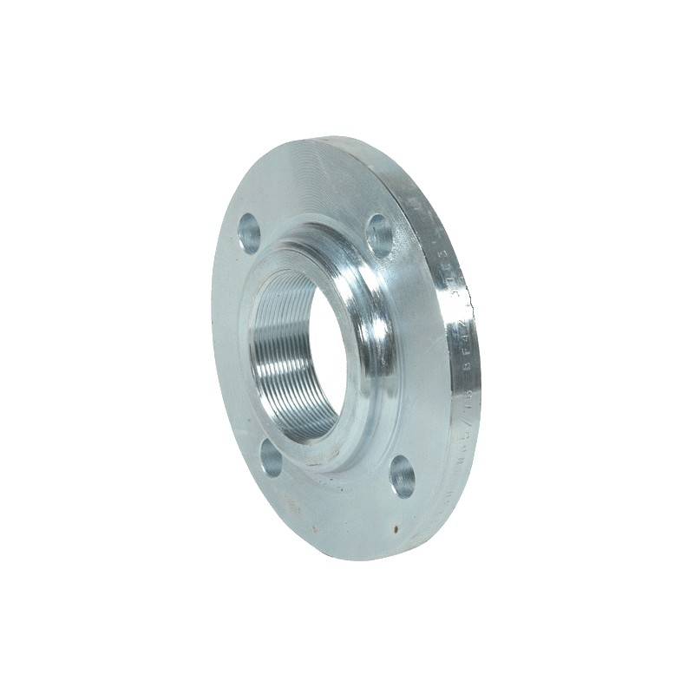
INOX pas US 1’’ PT / BSP 1’’PT

Other fixations possible, contact us

Note :
An adaptor DN40 is available for flange mounting.
REF : FNR131BRIDE

Congestion

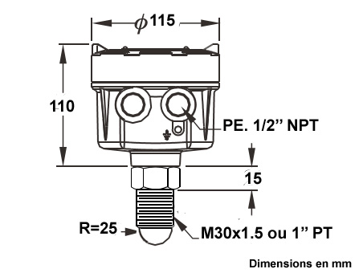
FNR131K FNR131P

FNR131H
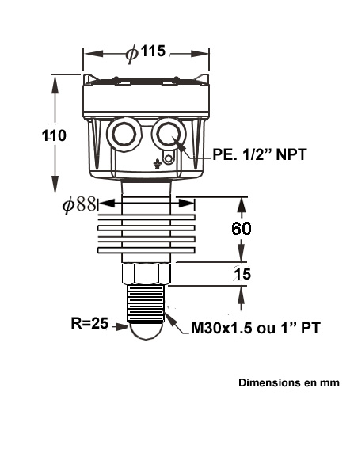

FNR131/GTR : Thread G 1½

Antenna Diagram
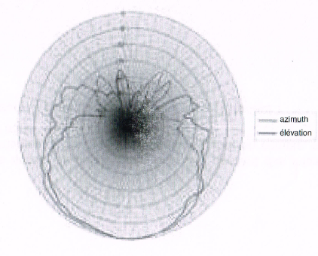

Installation

Pre-conditions
1/ The detector has to be assembled at a 45°-90° angle in relation to the direction of the material installed.

2 / The detector has to be assembled in a place without vibrations.

3 / No moving parts should be in the detection zone, this could be interpreted as a material flow,

If necessary, the moving pieces should be hidden from the detection zone by a metal sheet.
The sensor is to be encapsulated.

Pipe Mounting
Installation of the detector depends on site conditions.

For example the detector can be:
- Nailed directly on a thread M30 ou 1’’ PT
- Placed on a flange DN40
- Attached with a bracket ( free installation )

Check before installation that the temperature and the pressure in the piping does not exceed the limit permitted. It is necessary to add a protection system that can be penetrated by microwaves.
In the case of installation on pipes that are made of non-metallic ( PVC, Rubber... ), the measurement is made through the walls of the piping. It is therefore not necessary to create a window in the latter.

Conveyor Belt Installation

The detector must be mouonted in the loading or unloading area of the conveyor belt so that it does not detect the movement of the vacuum belt.
If not, install the detector with an angle of 70-80° minimum.

Electrical Connection
Connection on a screw terminal block.

Please connect to the ground.

0 | Mise à la terre du boîtier
1 | Power Supply - 0V
2 | Power Supply + 24V
3 | Static Output Q0
4 | Relay Contact NF
5 | Relay common
6 | Relay contact NO

3-wire cable
3-wire cable( compatible with NPN / PNP ) static output ( Q0 )
The output Q0 can be turned over by SW5

Relay Cable ( separate circuit )
Connection in 24VDC
Output on isolated contact SPDT on electro-mechanical outlay,

Note :
Select the NO or NF depending on the default action when the detector is not powered on or off. Then depending on the position of the SW5,

Commissioning

Selector SW1
1 | Sensitivity adjustment « Adjustments»
  SW1 | SW2 | SW3 | SENSIBILITY
  OFF | OFF | OFF | MAXIMUM
  OFF | OFF | ON | MEDIUM 1⁽¹⁾
  OFF | ON | OFF | MEDIUM 2
  ON | OFF | OFF | MINIMUM
2
3
4 | ON⁽¹⁾: Low filter pass on the signal  OFF: NO filter
5 | ON : ⁽¹⁾ OUTPUT ACTIVE = GREEN LIGHT  OFF : INVERSION FROM OUTPUT : ACTIVE = RED LIGHT
6 | Detection Mode :  ON ⁽¹⁾ : FLOW DETECTION  the output is instantly active when the product is moving.  The timer ( P2 ) is engaged when the product has stopped.  The output is de-activated at the end of the timer and when the product stops.  OFF : LEAK DETECTION  The timer ( P2 ) is engaged when the product is moving.  At the end of the timer, and if the product is still moving the output is activated.  The output is de-activated when the product has stopped.

Note : (1) factory value

LED Lighting
LED1 | SIGNAL DETECTION  Red Light : Detection of a moving productt ( does not have to be constantly on )
LED2 | OUTPUT  GREEN Output not active  RED Output active  ORANGE Timing in progress  OFF Detector off

Potentiometer
P1 | SIGNAL THRESHOLD  Clockwise direction should be on RED LIGHT,  Adjust the detection threshold in the presence of the moving product to be detected.
P2 | TIME SETTING 0 à 30 secondes  Counter clock-wise : No timing  Clockwise : Maximum timing

SETTING
Switch the system on so that the product is transported normally.

The LED1 has to flash at each passage of the product. In order to do this, set the threshold with the potentiometer P1. When the product stops LED1 must be turned off immediately.
If you do not have any change in the LED select a different sensebilty by SW1 SW2 SW3.
Repeat the regulation operation until the LED1 functions normally.

The product is moving at a fast rate ( pneumatic transport ) it is necessary to use the the low-pass filter by SW4.

Put P2 at minimum( counter-clockwise direction ) , check that the output and the LED2 change state with the changement of LED1. Finally, set the timer to P2

Depending on the desired operating mode, select a different operating mode with SW5 and SW6. It is not necessary to switch off/ turn on each time the mode/function changes .

Troubleshooting
If LED1 is turned on without any product flow, adjust P1 in the counter clockwise direction and check if the detector did not pick up on vibrations or a piece of moving product.

If LED1 is not turned on although there was product flow, adjust P1 in the clockwise direction and check to see the cleanliness of the sensor as well as it's position.

If LED2 s not turned on ( RED or GREEN or ORANGE ) this indicates a lack of power to the detector.


TELEMETRIX SAS
BP 118
79, Rue de la Gare
78374 PLAISIR CEDEX FRANCE
TEL (+33) 09 72 11 00 03 FAX : (+33) 09 72 11 00 57

CERTIFICAT DE CONFORMITÉ EUROPÉEN – EC

Product Code | Description & fabricant
FNR131 | Détecteur de débit

Sécurité
CEI 1010-1, EN 61010-1 : Règles de sécurité pour les équipements électriques de mesure, de contrôle Partie 1.

Compatibilité Electromagnétique
Emission et immunité conformes à EN 61326 & DIN55011 : Équipements électriques de mesure, de contrôle et utilisés en laboratoire, Partie 1

Immunité au regard des sources industrielles EN 50082-2
Décharge électrostatique EN 61000-4-2 Niv 2 : Au contact : 4 kV Niv 3 : Dans l.air : 8 kV
Champ électromagn. RF EN 61000-4-3 Niv 3 : 10 V/m 1.De 80 MHz à 1 GHz
Transitoires rapides (rafale)
EN 61000-4-4 Niv 4 : 2 kV (E/S) Niv 3 : 2 kV (alimentation)
Interférences RF conduites EN 61000-4-6 Niv 3 : 10 Vrrms de 150 kHz à 80 MHz
Simulation d.un téléphone sans fil EN 55011 Niv 3 : 10 V/m
900 MHz ± 5 MHz
200 Hz, rapport cyclique 50%

Emissions en référence à EN 50081-2
Interférence RF EN 55011 Boîtier Classe A
Alimentation Classe A
Nota :
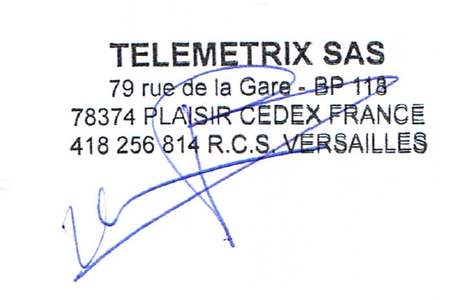
1. Pertes de performance récupérées lors d’une perturbation EMI à 10 V/m Les mesures peuvent accuser une déviation durant la perturbation EMI. Pour un fonctionnement sans perte de performance, l’appareil doit être installé dans une zone conforme. Les câbles de puissance et faible signaux doivent cheminer dans des conduits métalliques raccordés à la terre par des tresses de masses. Pour plus d’informations, consultez les documents relatifs aux installations pour la CEM.

[SF] Paddle Flow Switch
[FC/FD] Mini Float/Magnetic Float Level Switch
[SD] Optical Level Switch
[FA/FB] Cable Float Level Switch
[FF] Side Mounting Float Switch
[SE] Rotary Paddle Level Switch
[SA] Capacitance Level Switch
[SP] Thermal Dispersion Flow Switch
[EC] Pressure Level Transmitter
[FG] Magnetic Float Level Transmitter
[SB] RF-Capacitance / Admittance Level Switch
[SC] Vibrating Probe Level Switch
[SC] Tuning Fork Level Switch
[ED] Speed Monitor
[PB/PM] Microprocessor Based Bargraphic Display Scaling Meter
[BRD/AE] Valve and Controller for Dust Collector System
[EB] RF-Capacitance Level Transmitter
[EG] Magnetostrictive Level Transmitter
[EA] Ultrasonic Level Transmitter
[EF] By-Pass Level Transmitter
[MEF] Mini By-Pass Level Transmitter
[BAS/BAH/BVP] Air Hammer
[BVK/BVR/BVT] Pneumatic Vibrator
[JFR] FMCW Radar Level Transmitter
[EE] Electromechanical Level Measuring System
[SRT/SRS] Conveyer Belt Misalignment Switch &
Safety Cable Pull Switch
[FA/FB]
[EG]
[SF]
[EF]
[JFR]
[FC/FD]
[EC]
[FF]
[SA]
[EA]
[SP]
[SC]
[SB]
[FC/FD]
[SD]
[EB]
[SE]
[PB/PM]
[EB]
[EE]
[EA]
[BAS/
BAH/BVP]
[BVK/
BVR/BVT]
[EB]
[SA]
[SB]
[SC]
[SC]
[SC]
[JFR]
[SE]
[SB]
[JFR]
[PB/PM]
[FG]
Selection Guide
for Solid/Liquid Level Measurement

TELEMETRIX SAS
79, RUE DE LA GARE
BP118
FR-78370 PLAISIR

Tel. (+33) (0) 972 11 00 03
Fax (+33) (0) 972 11 00 03
www.direct-mesure.fr
contact@direct-mesure.fr

N° TVA FR85418256814
RCS B 418 256 814
SIRET 418 256 814 00041


Distributor:

TELEMETRIX_NOTICE_FNR131_c

